**Academic Year 2021**

**Department: Computer Sciences**

**Instructor: Madam Syeda Hafsa**

**Name of Assignment:** Motherboard and its components.

**Full Name:** Muhammad **Subject:** Fundamental of ICT (Lab)

**Father’s Name:** Abdul Rasheed **Section:** 2021

**CMS ID:** 391855 **Date of Submission:** 01/12/2021

**What is the motherboard?**

**MOTHERBOARD:** In simple words, it is the main circuit board for a computer, it is also called, CPU board. Orthe motherboard is the vertebral column that linkup the computer's components together at one patch and allows them to interact to each other. Without CPU board, not any of the computer parts, such as the CPU, GPU, or hard drive, could act together. The complete motherboard functionality is needed for a computer to work well and perfectly. It is the motherboard that connects all the components of the computer, that is to say, peripheral equipments which are known as input and output devices and storage devices and many more. Without any doubts, the absent of motherboard a computer cannot work. That is why, the above discussed one is the chief means of computer. 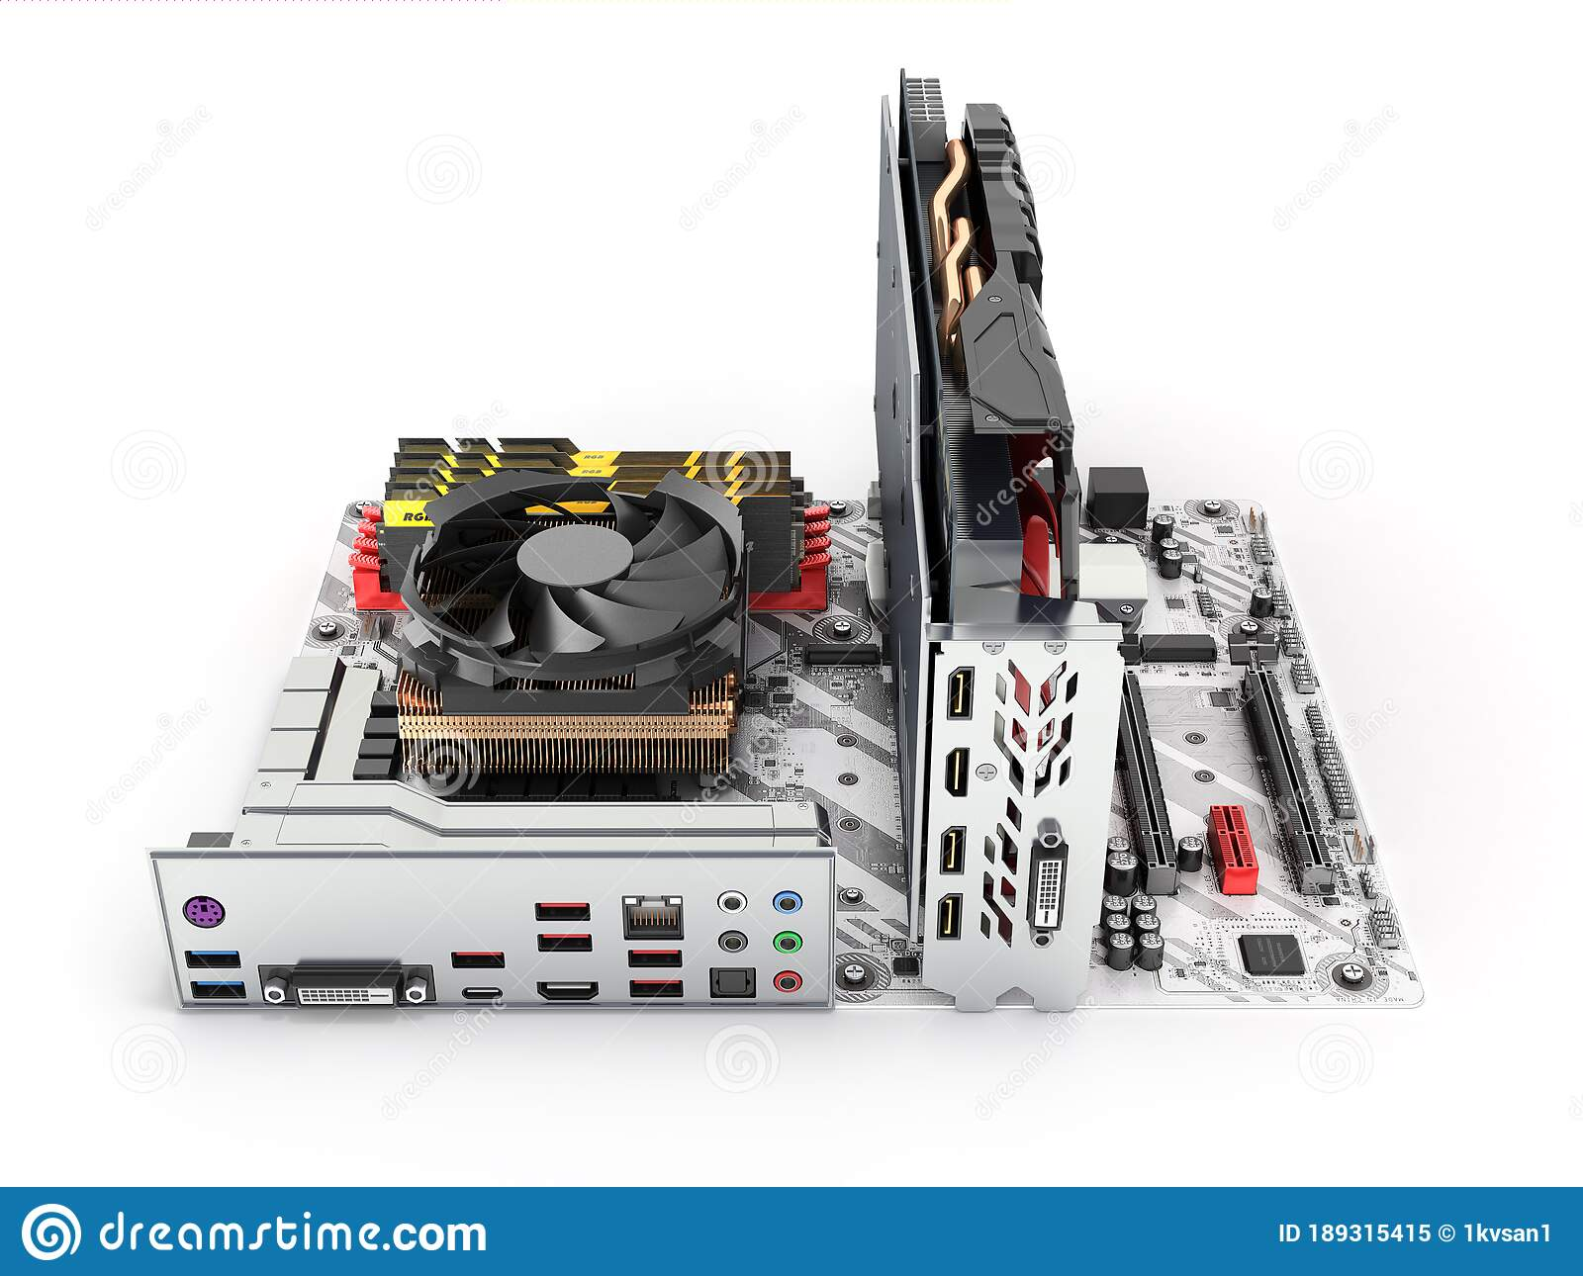

**What are the components of it?**

The major components are Optical drives, such as DVD and CD-ROM drive, Video cards and GPUs, sound cards, hard drives (SSD or HDD), processors (CPU), USB (Universal serial bus), memory sticks (RAM), Parallel port, floppy controller, CPU slot, power supply plug in and theconnector Side of Motherboard and so on.

**DVD:** It stands for digital video disc, used for recording movie and others that can be played on a computer or a television set.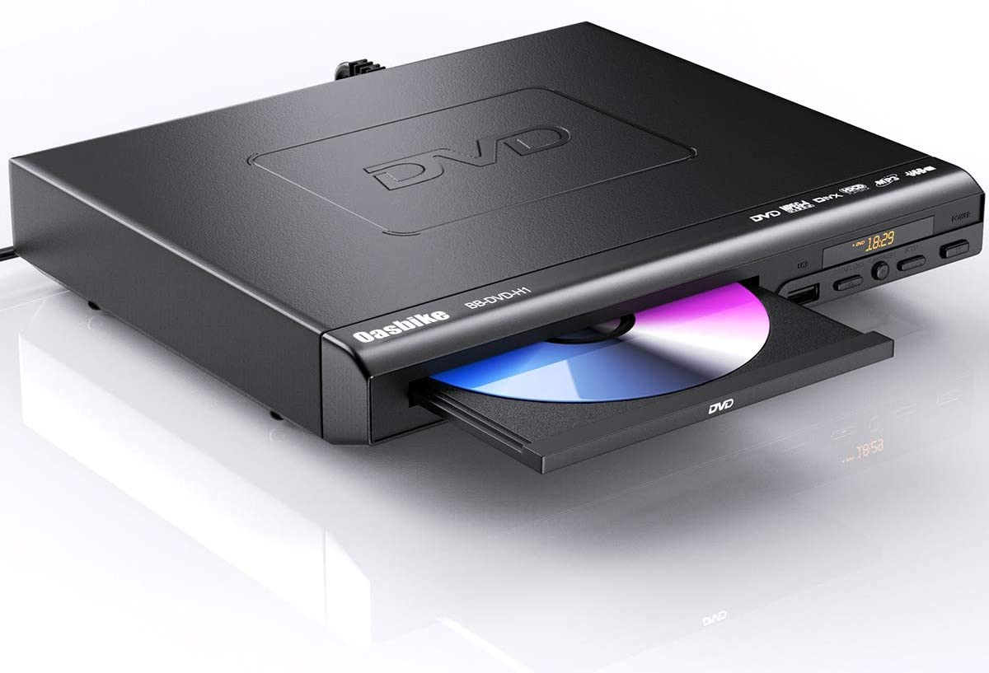

**CD-ROM drive:** “CD” stands for compact disc. CD-ROM drive is connected to a computer to play a CD-ROM.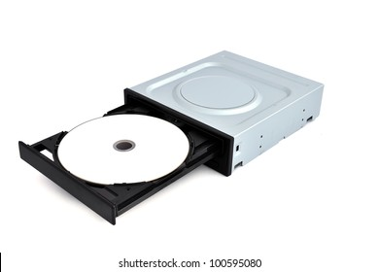

**Video Cards and GPUs:** These are also called graphics card. GPU (Graphics processing unit), provides a good graphic and used in video editing, and gaming applications.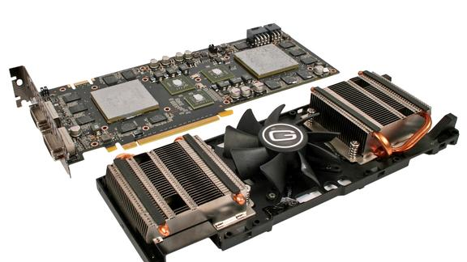

**Sound cards:** These are slotted into a computer to produce sound.

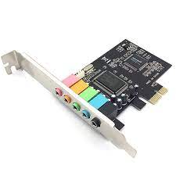

**Hard drives (SSD or HDD):** A hard disk drive (HDD), hard disk, hard drive, or fixed disk is an electro-mechanical data storage device that stores and retrieves digital data. Solid State drive (SSD) is a newer, faster type of device that stores data. 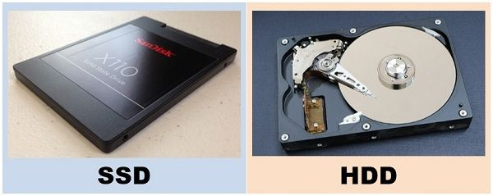

**Processors (CPU):** It is the brain of the computer and processes the instructions which are given to the computer.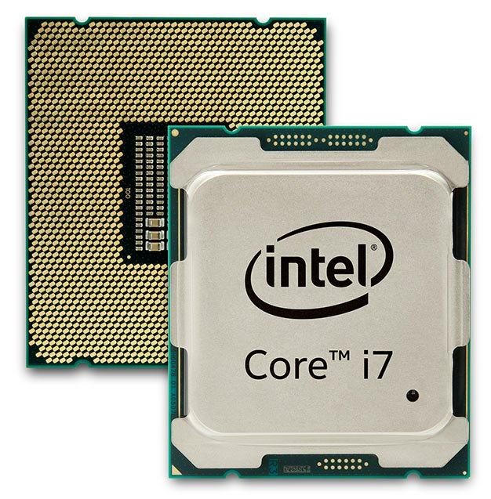

**USB (Universal serial bus)**: It is used to store data, keep the backup of it and communicate with other sources. 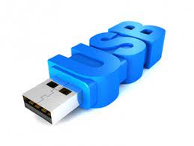

**Memory sticks (RAM):** Random Access memory (RAM) stores the data to manipulate it into useful information temporally.

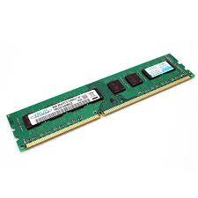

**Parallel Port:** It is a very old port can be found in early computer and functions to connect peripherals.

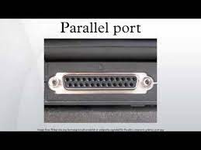

**Floppy controller:** It is an electronic chip controller used as an interface between a computer and a floppy disk drive.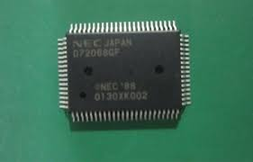

**CPU Slot:** It is slot on the motherboard to bring connection between CPU and motherboard.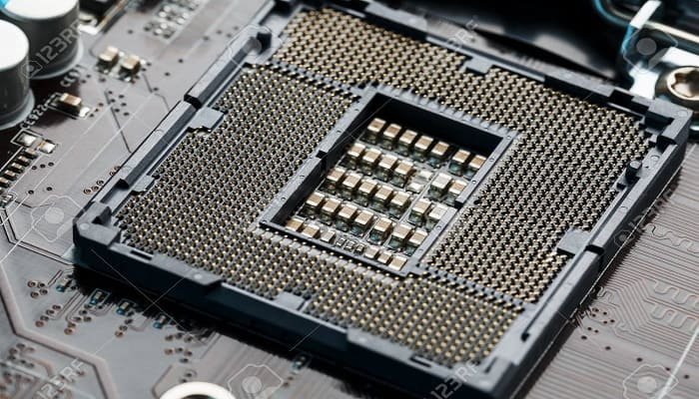

**Power Supply Plug In:** It provides supply to the motherboard.

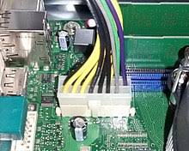

**The connector Side of Motherboard is shown in the picture below;**

